ANNAMACHARYA
INSTITUTE OF TECHNOLOGY & SCIENCES
(AUTONOMOUS)
New Boyanapalli, Rajampet Annamayya (Dist)– 516126

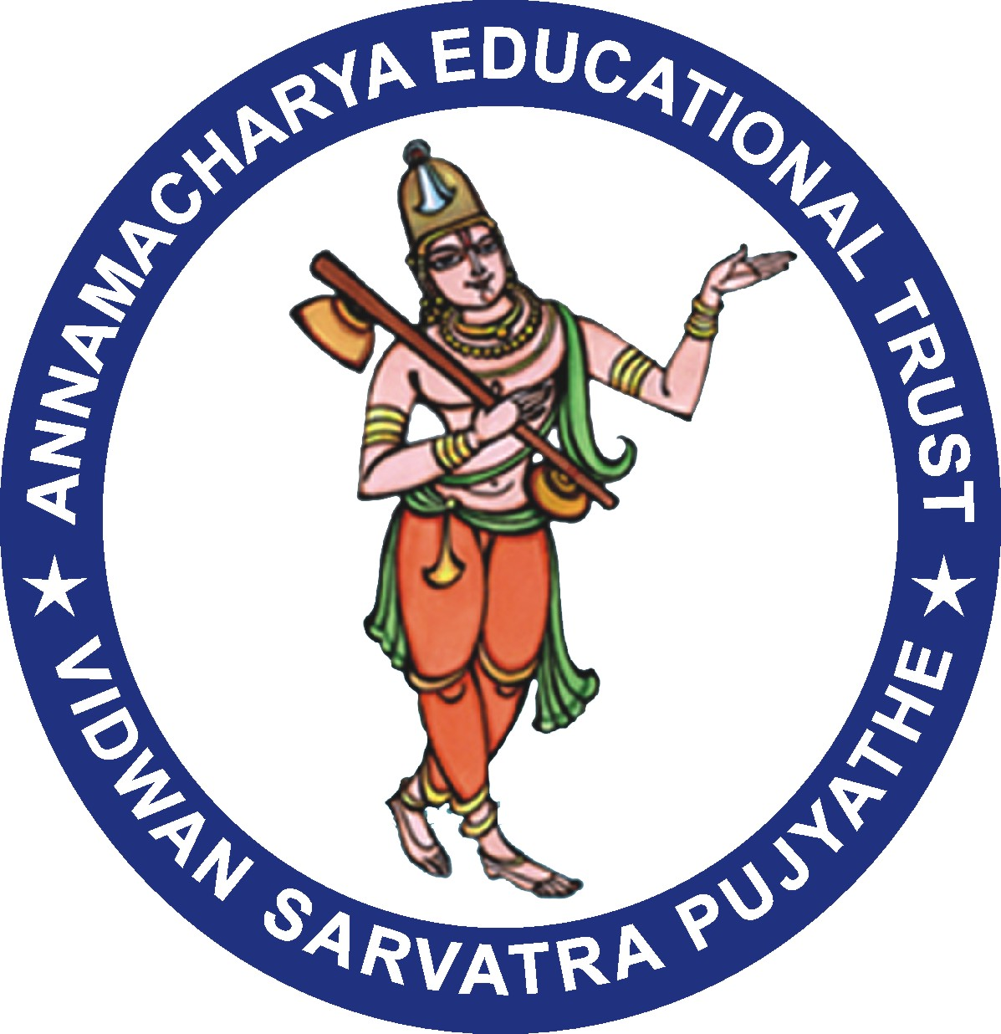

Department of Business Administration

Alumni Meeting Report – 2019

AITS Alumni Association has conducted alumni meet to all students of AITS at the Gallery on 15.12.2019 in the forenoon session from 9:30am to 12: 00 pm. Followed by lunch arranged in the college premises. Later the department level Alumni Meet 2019 is started with Registration process for MBA from 1:30 PM to 2:30 PM at MBA Smart room. More than 47 Alumni are registered. At 2.45 PM, the Alumni Meet 2019 is inaugurated by the dignitaries Dr. SMV. Narayana, Principal-AITS, Dr. P. Subramanyam, HOD-MBA, Dr. K. Prasad, AITS Alumni Coordinator, and Alumni of AITS initiated the inauguration with lighting the lamp and pooja. After Dr. P. Subramanyam has delivered the welcome address to all the Dignitaries, Alumni and Faculty. Mrs. V. Vedavathi, AITS MBA Alumni Departmental Coordinator has presented the activities initiated and executed at the MBA department.

Followed by, the dignitaries had given their inaugural address to the gathering. After Inauguration, Mrs. V. Vedavathi, AITS MBA Alumni Departmental Coordinator addressed the gathering about the Alumni roles and responsibility in connection with AITS -MBA and their contribution towards the Past, Current and Future development for the betterment and support required for the rural students.

The Alumni who attended for this programme shared their experience with respect to Awards and rewards received by them, current trends, scenarios and expectation in the corporate industries, memories of campus life during their education tenure in AITS-MBA and further development required from MBA to meet out the challenges in the current corporate industries. At 4.30 PM, the Snacks was arranged in PG block. Later at all the Alumni gathered and shared their experiences. The Alumni meet ended with Vote of Thanks.

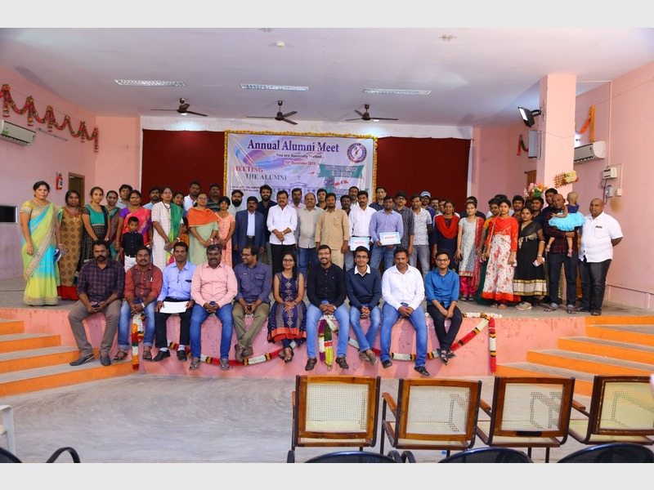
(Alumni meet on 15.12.2019)

Outcomes:
- Alumni meet is a gathering of passed out students of an institution and it is a place where the institution feels proud on seeing its successful alumni.
- Alumni Meet, creates a special bonding between the students who have passed out & who have established themselves already in the big, outside world.
- During the meet, the alumni shared their experience in the outside world, which they faced after stepping out of the institution with our students.
- After the interaction, they volunteered themselves to help the fellow students regarding Internships, Placements, Guest lectures & Workshops.

Department Alumni Coordinator

