ANNAMACHARYA
INSTITUTE OF TECHNOLOGY & SCIENCES
(AUTONOMOUS)
New Boyanapalli, Rajampet Annamayya (Dist)– 516126

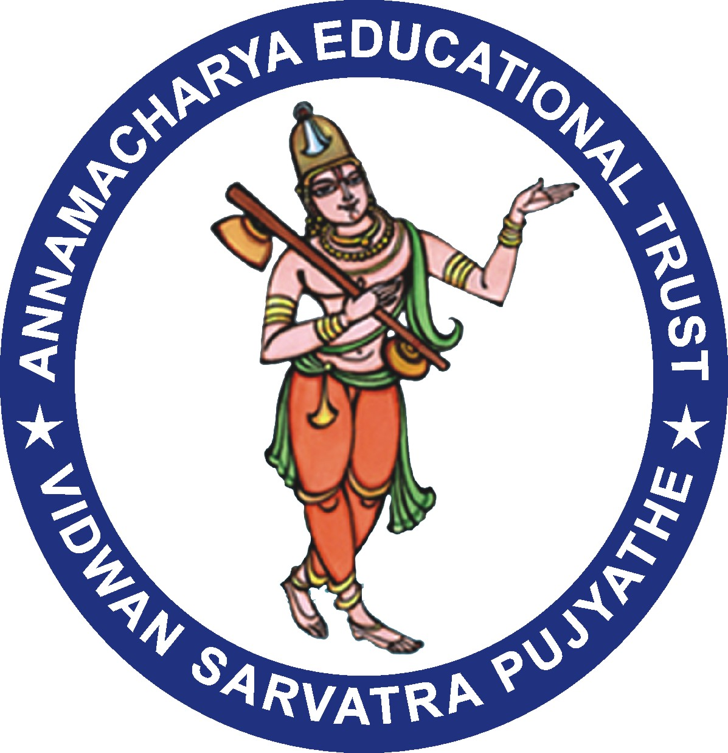

Department of Business Administration

Alumni Meeting Report – 2023

Every year on second Sunday of December AITS Alumni Association organizes Annual Alumni meet. This year it falls on 10th of December and the event is hoisted by AITS Rajampet in the morning session. The Department of Business Administration, Annamacharya Institute of Technology and Sciences, Rajampet has hosted “AITS-MBA Annual Alumni meet- 2023”, at AITS gallery in the main block after the lunch in the afternoon session.

After the lunch the Alumni started arriving to AITS gallery by 1.30 pm and they were received by the registration team. 36 alumni attended the meeting. The inauguration function started with the an in-vocation song seeking the blessings of almighty and lighting of the lamp by the dignitaries on the dais. Mrs. V. Vedavathi, MBA Department Alumni Coordinator has presented the activities initiated and executed in the department during the academic year 2022-23. She has presented the opinions expressed by the alumni members in the previous annual meet which is held on 11th December, 2022. A total of 36 Alumni attended to the Annual Alumni meet 2023 at AITS Rajampet.

Dr. SMV Narayana Principal of AITS addressed all the Alumni and gave insights about various developments taken place in the College in the recent few years.

The Alumni who attended for this programme shared their experience and expectation in the corporate industries, memories of campus life during their education tenure in AITS-MBA and further development required from MBA to meet out the challenges in the current corporate industries.

Dr. P. Subramanyam Head of the Department of Management Studies assured that the Suggestions given by the Alumni will be discussed in the department meeting for future actions and Implementation. Then the alumni meeting was ended with vote of thanks.
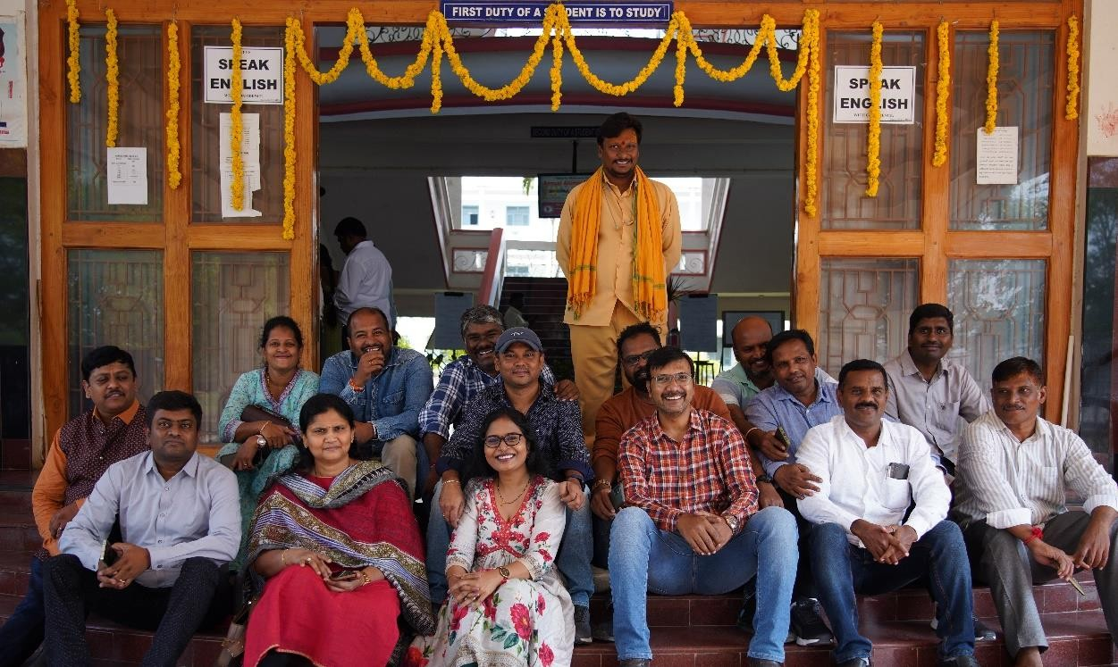
Alumni at the entrance of AITS main building

Suggestions:
- Alumni expressed their suggestions in conducting good number of programs on career guidance and entrepreneur development.
- Alumni suggested to conduct talks and awareness programs on the usage of Business Intelligence.

Department Alumni Coordinator

