Annamacharya Institute of Technology and Sciences: Rajampet
(Autonomous)
Entrepreneurship development Cell
Annual Report-2022-2023

Preamble:
During a recession, an economy typically experiences high unemployment rates, eventually leading to job scarcity. There are numerous theories about the causes, consequences and solutions to unemployment.
Start-ups gradually help to increase a nation’s economic activity levels, which is required for the economy to expand to accommodate new job seekers. It contributes to a nation’s technological advantage for future economic development and growth. Entrepreneurs play a critical role in igniting economic development by establishing new businesses, creating jobs and contributing to improvements in a variety of key goals such as living standards, skill development and community development.
The entrepreneurship cell of AITS, Rajampet is primarily concerned with energizing students and faculty by raising awareness about the development of start-ups. By providing the right entrepreneurial ecosystem, the entrepreneurship development cell aims to ignite student’s creative thinking toward innovation and thus mentor them to become successful entrepreneurs.
About ED Cell- AITS Rajampet:
Entrepreneurship development cell has set up in Annamacharya Institute of Technology and Sciences, Rajempet, to promote and educate young students to take the benefit of the policies of the government by establishing their own ventures.
- Vision
  - Producing successful entrepreneurs imbibed with leadership qualities using innovative and ethical business practices to make global impact.
- Mission
  - Install the passion and spirit among students to pursue entrepreneurship
- Long terms goals
  - Motivate students to develop their own start-ups
  - Develop business incubators
  - Create corpus fund to seed ventures
- Short Term goals
  - To provide a platform for interaction with entrepreneurs
  - Impart entrepreneurial education/skills amongst students through various trainings and exercise
  - Arrange vibrant interaction with organizations promoting the cause of entrepreneurship.
Aims & Objectives
- To create entrepreneurship awareness to students.
- To create self-employment awareness.
- To motivate students to make their own career path and create awareness of self-financial schemes of various agencies.
- To organize entrepreneurship awareness camps, Entrepreneurship development programmes, Faculty development and skill development programmes.
- Prospective entrepreneurs can get guidance and assistance on various aspects such as preparing project approvals, loans and facilities from agencies/support system, information on technologies, etc.
- To arrange expert lectures and interaction with entrepreneurs and create a mentorship scheme for student entrepreneurs.
- To arrange visits to small scale industries. To act as an institutional mechanism for providing various services including information on all aspects of enterprise building to budding S&T Entrepreneurs.
Policies and guidelines of ED cell:
To fulfil the objectives of EDC of AITS, Rajampet, and the framework includes 4 major standards:
- Formal education
- Facility
- Technology transfer
- Social Entrepreneurship and Inclusivity

- Formal Education
- Most of the students are not moving toward the entrepreneurship due to lack of knowledge, how to convert their idea or innovation in to product. However through the EDC. We provide the trainings to the students as per the requirement of the industry and market. These formal trainings and guidance will provide the appropriate way to lead to the success.
- Encourage the students to become self-employed through various hands on, workshops.
- Invite the well-known trainers and entrepreneurs from various institutes to train the students as well as teachers.
- Support to entrepreneurs, including coordinated delivery of national and state government entrepreneurship programs and access to enabling resources, a national network of Entrepreneurship.
- Facility
- We provide maximum infrastructural facilities to the students, including various laboratories, hardware and software.\
- Special focus will be on early stage ideas and innovations which can be definitely converted to the products.
- Government schemes for funding are introduced to the students by the trainers and necessary advocacy is been provided.
- To arrange interaction with entrepreneurs and create a mentorship scheme for student entrepreneurs.
- Technology Transfer
- The entrepreneurs should get familiar with the industrial scenario that is the new techniques, business requirement and market demand. Special efforts will be provided to streamline the innovations into products.
- Key-note speakers from the industry are involved into the training sessions for the students, so as the market conditions will be discussed with the students.
- Make student approach to the industry very easy through incubation cell in the institute.

- Social Entrepreneurship and Inclusivity
- Introducing students with the social entrepreneurship, this deals with issues of poverty, unemployment and inequity in society.
- ED cell is including good number of students from all the branches.
- As per interest of students various training sessions are organised by the college and students as well. Students get the appropriate guidance as per requirement.
- Girl entrepreneurs are also promoted and motivated to form an enterprise.
Functions:
- To organize Entrepreneurship Awareness Camps, Entrepreneurship Development Programmes and Faculty Development Programmes in the region for the benefit of S&T persons.
- To develop and introduce curriculum on Entrepreneurship Development at various levels including degree/diploma courses of the parent institution and other institutes in the region.
- To conduct research work and survey for identifying entrepreneurial opportunities (particularly in S&T areas and Service sector).
- To guide and assist prospective entrepreneurs on various aspects such as preparing project reports, obtaining project approvals, loans and facilities from agencies of support systems and information on various technologies.
- To organise guest lectures, TV & Radio talks, Seminars, etc. for promotion and growth of S&T based entrepreneurship.
- To arrange visits to industries for prospective entrepreneurs.
- To extend necessary guidance and escort services to the trainees in obtaining approval and execution of their projects.
- To act as a Regional Information Centre on business opportunities, processes, technologies, market, etc. by creating and maintaining relevant databases.
- To provide testing, calibration, quality assurance, design, tool room, pilot plant and other facilities for Entrepreneurs besides expertise in Intellectual Property rights, Patents search, etc.
- To render advice to sick enterprises and assist the entrepreneurs in rehabilitating them.
- To conduct skill development training programmes leading to self/wage employment.

EDC- Committee:

S. No | Name | Designation | Department | Position
1 | Dr.SMV Narayana | Principal | CIVIL | Chairman
2 | Dr.G.Kanuka Raju | Associate professor | MBA | Member
3 | Ms.P.Mabjan | Assistant Professor | MCA | Member
4 | Ms.N.Kusuma | Assistant Professor | CIVIL | Member
5 | Mr.M.Mani | Assistant Professor | ME | Member
6 | Mr.S.Muqthiar Ali | Assistant Professor | EEE | Member
7 | K.Chandrahasa Reddy | Assistant Professor | ECE | Member
8 | Dr. K.Bala | Associate professor | CSE | Member
9 | Mrs.N.Swathi | Assistant Professor | AIDS | Member
10 | Mr.K.Lokeswar Reddy | Assistant Professor | AIML | Member
11 | Dr.P.B.Chennaiah | Associate professor | EEE | Member Secretary

Events organized:
S. No | Programme title | Resource person | Number of participants | Branch | Month & year
1 | Webinar on cyber security | Mr.Sai Sathish, Founder & CEO, Indian servers, Hyderabad | 30 | BTech EEE and MBA students | 28/2/2023
2 | Guest Lecture on Innovative Techniques for mechanical Engineers | Dr.D.Krishna Mohan Raju, Professor, Department of ME, AITS, Rajampet. | 50 | III B.Tech, ME Students | 29/11/2022
3 | Gust lecture on Cyber physical systems | Dr.Satyanarayana Vollala, Assistant Professor, Department of CSE, IIIT, Raipur, Chhattisgarh | 120 | IV B.Tech, CSE Students | 18/08/2022

Details about the events organized:
1.One day webinar on Cyber security was conducted by Entrepreneurship development cell in Association with Department of department of Electrical & Electronics engineering on 28/2/20203. A total of 30 participants have participated in the webinar. Resource person Mr.Sai Satish, Founder & CEO, Indian servers delivered a topic on “Cyber security”. Dr. M.subbarao, Dean Non statutory & professional bodies, Dr.P.Balachennaiah In-charge EDC, Mr.Muqthiyar Ali coordinator of EDC for EEE department organized this event. Resource person has given vast information related to Cyber Security that enlightened faculty & students.
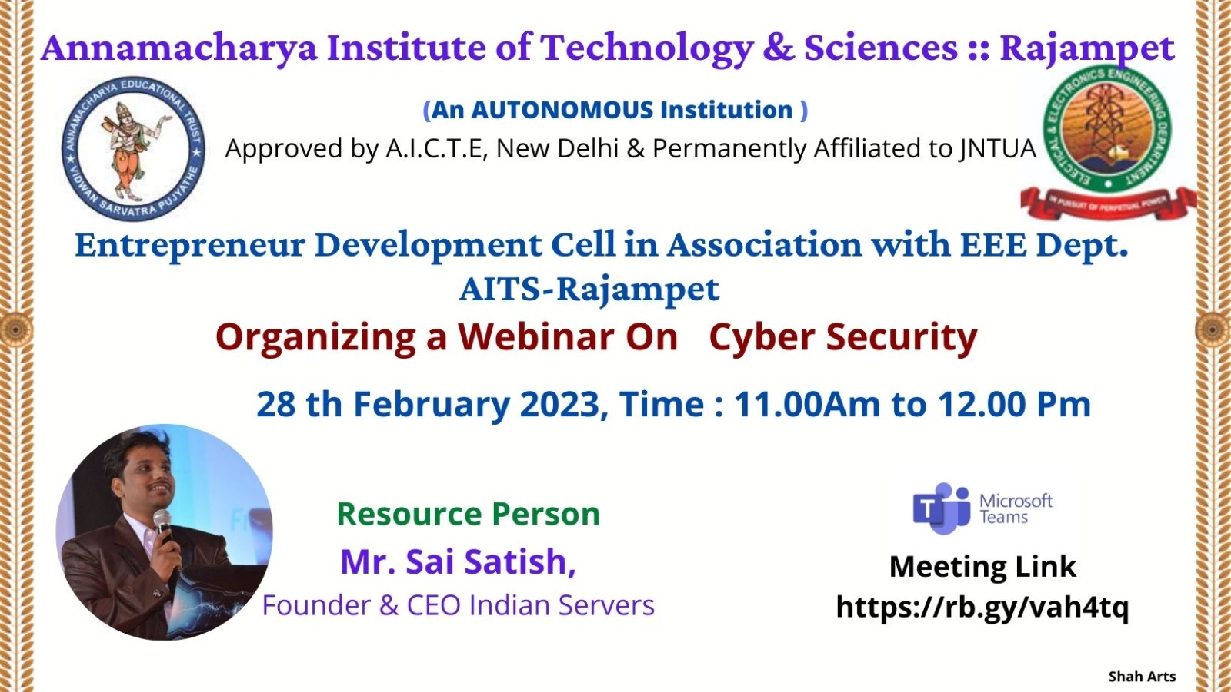
Photo 1: Event Brochure
2. Guest lecture on “Innovative Techniques for mechanical Engineers” was conducted by Entrepreneurship development cell in Association with Department of department of Mechanical engineering on 29/11/2022. A total of 50 III B.Tech ME students have participated in the Guest lecture. Mr.P.Mani Mohan, Assistant professor, department of Mechanical Engineering conducted the event.

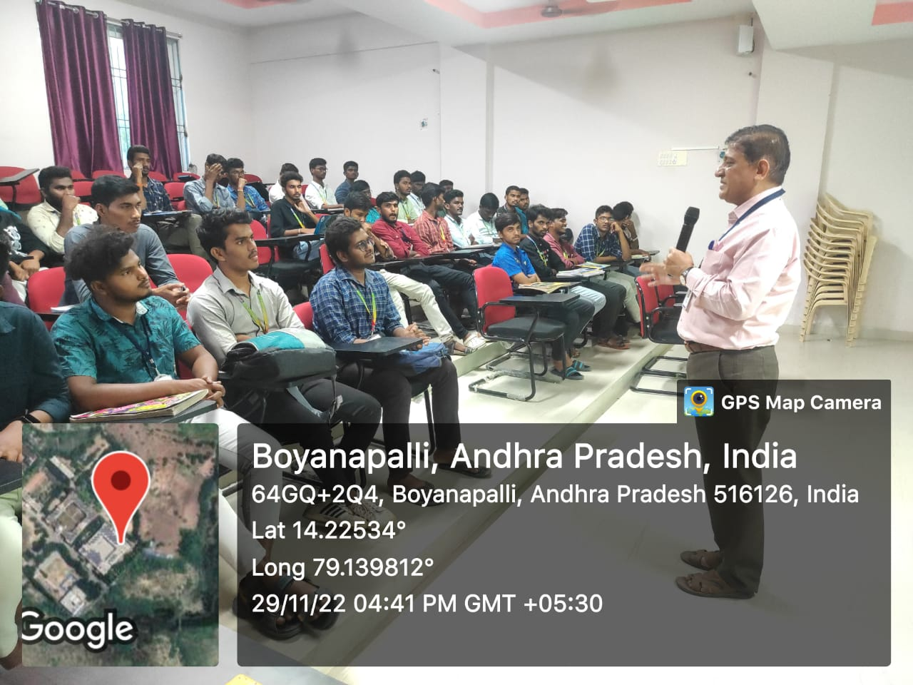
Photo1: Dr.D.krishna Mohan Raju, Professor, Department of ME, AITS, Rajampet, delivering lecture to students
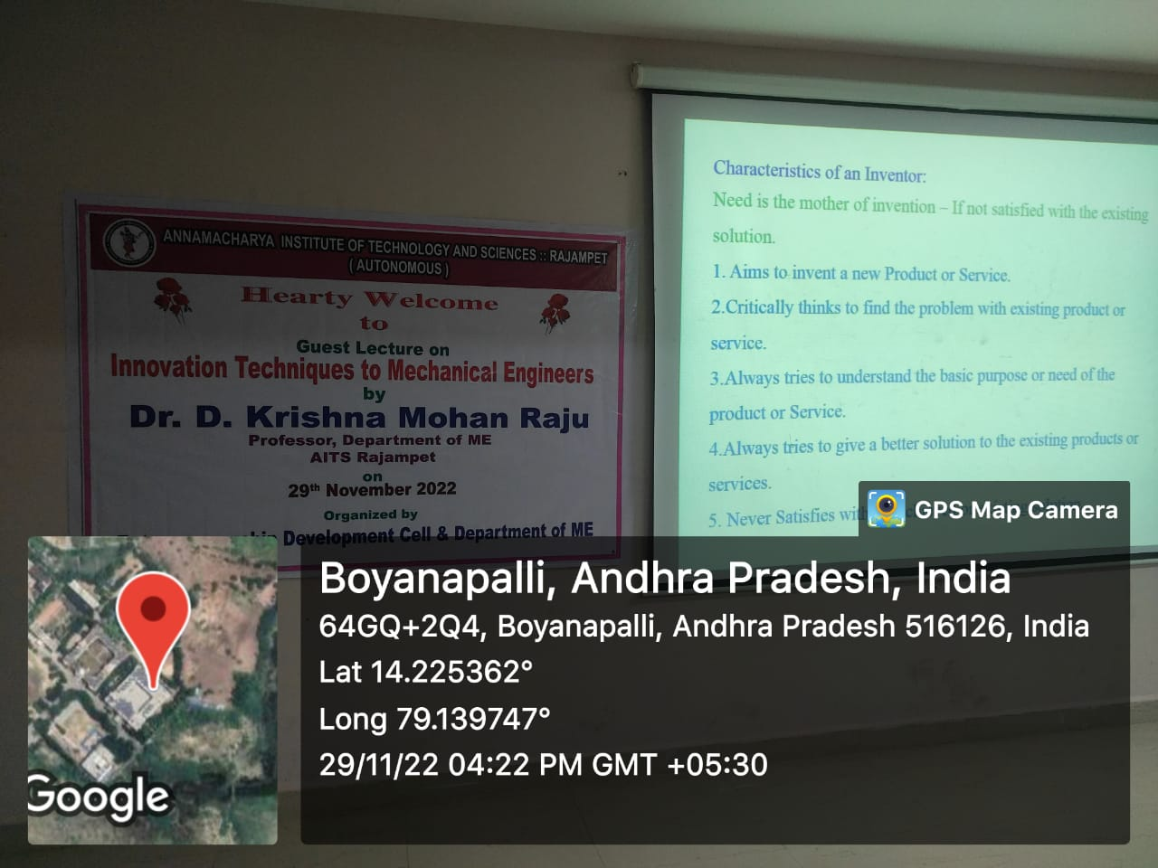

Photo 2: III. B.Tech, ME students participated in the guest lecture

3. Guest lecture on “Cyber physical systems” was conducted by Entrepreneurship development cell in Association with Department of department of Computer Science engineering on 18/08/2022. A total of 120 IV B.Tech CSE students have participated in the Event. Dr.Satyanarayana Vollala, Assistant Professor, Department of CSE, IIIT, Raipur, Chhattisgarh delivered the Guest lecture.
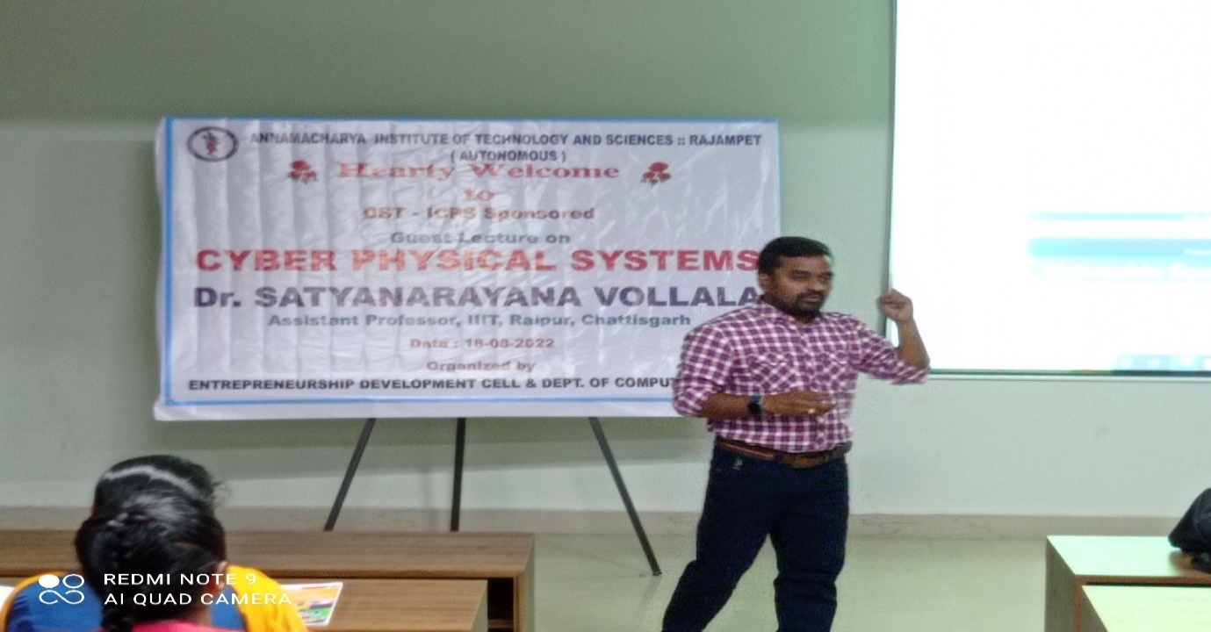
Photo 1: Dr.Satyanarayana Vollala, Assistant Professor, Department of CSE, IIIT, Raipur, Chhattisgarh, delivering lecture to students
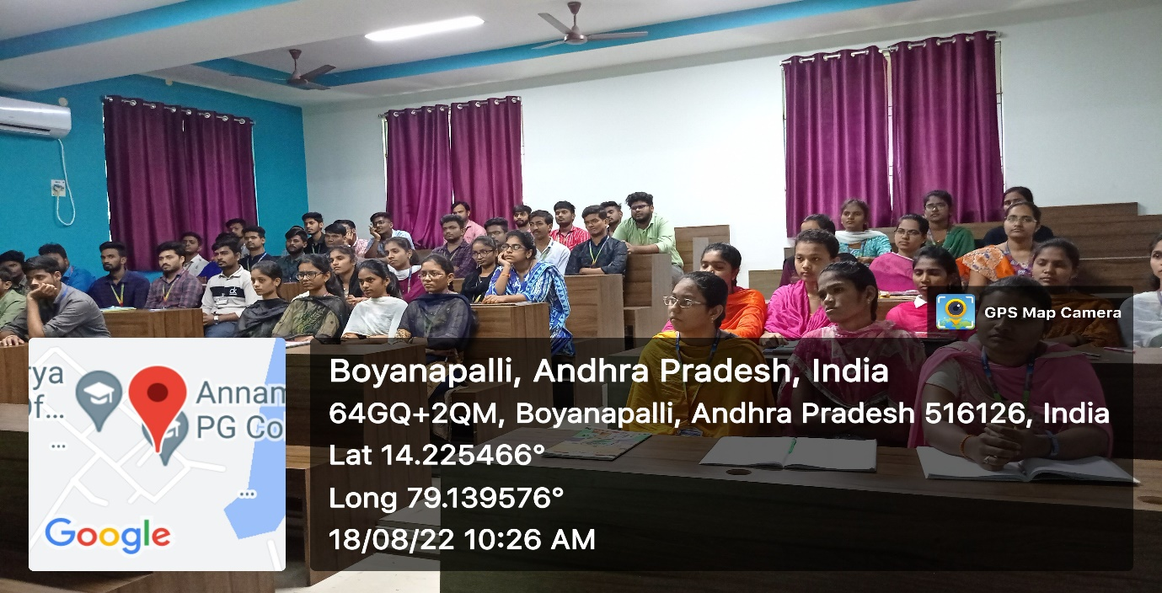

Photo 2: IV. B.Tech CSE students participated in the guest lecture

