ANNAMACHARYA INSTITUTE OF TECHNOLOGY & SCIENCES::
(AN AUTONOMOUS INSTITUTION) RAJAMPET.
AFFILIATED TO JNTUA ANATHAPURAMU.ANDHRA PRADESH.
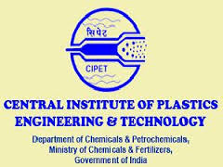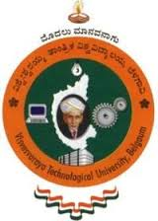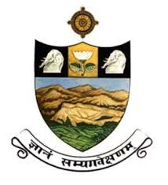

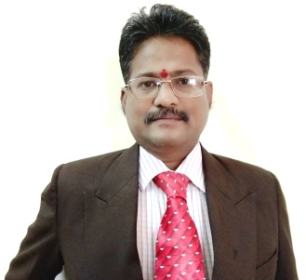

Dr. N.VENKATACHALAPATHI
B.Tech., M.Tech(VTU)., Ph.D(SVU).,PGDPE(CIPET).,PGDIRPM.,F.I.E.,
PROFESSOR AND DEAN (R&D)
DEPARTMENT OF MECHANICAL ENGINEERING

FORMER PRINCIPAL (BITS,WARANGAL)(NIT SATTENAPALLI)
FORMER PROFESSOR (R&D) VELAMMAL ENGINEERING COLLEGE CHENNAI
FORMER PROFESSOR (R&D) VELTECH TECHNICAL UNIVERSITY, CHENNAI.

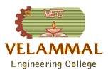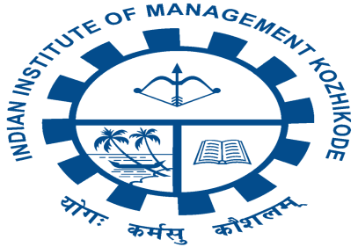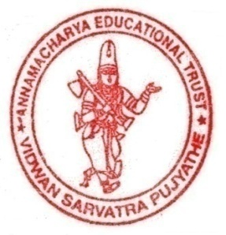
VENKATACHALAPATHI NYNARU

Email:
nvcprincipal@gmail.com

Permanent Address:

House No.3-607,
Peerla Chavadi Street
Srikalahasti-517644
Chittoor District
Andhra Pradesh
India

Telephone:

Home:+91 7812815320

Work: +91 8056075899

Personal Data:
Date of Birth: 15th Feb 1970
Sex: Male
Nationality: Indian

Marital Status: Married

Current Designation:

Professor and Dean (R&D)

AITS,
Rajampet-516126
Kadapa Dist. A.P.,

India.

Job Responsibilities:

Teaching and Learning
Research and Development
Industry Institute Collaborations Faculty Evaluation

Result Analysis
Quality Assurance
Budgeting (Research and Lab)

Technical Proposals Review and approval

Institution accreditation AICTE, University, UGC, NBA liaisons.
Education

- PhD in Mechanical Engineering, Sri Venkateswara University,Tirupati, Andhra Pradesh India, 2009 Thesis: Some studies on Simulation, Scheduling and Optimization of Flexible Manufacturing System

- Master of Technology in Production Management,Visveswaraiah Technological University,Belgaum, India, 2000
- Bachelor of Technology in Mechanical Engineering, Sri Venkateswara University, Tirupati, India,1988-1992
Professional Experience – 23 years

- Working as Professor and Dean (R&D) at Annamacharya Institute of Technology and Sciences, Rajampet from 1-6-2016 to till date.
- Worked as Professor (R&D) at Vel Tech University from 8th January, 2015 to 31st May 2016.
- Worked as Professor (R & D) At Velammal Engg. College, Surapet, Chennai from 5th July 2012 to 07-01-2015 ( 3 Years)

- Worked as Professor of ME & Principal, BITS,Narsampet,NIT Sattenapalli,KKC Puttur from 1st August 2008 to 4th July 2012. ( 4 Years)
- Worked as Assistant Professor in Mechanical Engineering, Sri Kalahasteeswara Institute of Technology, Srikalahasti from 14th March 2001 to 31st July 2008. (7.4 Years)
- Worked as Lecturer in Mechanical Engineering, NBKRIST,Vidyanagar, from 1st July 1995 to 30th April 1998 and SVCET,Chittoor, PBRVITS,Ka ali from 9th September 1999 to 13th March 2001.(4.5 Years)

- Worked as Production Engineer in M/s DJ Multipack Ltd, Chennai from April 1992 to August 1995 (2.8 Years)

Achievements

- Achieved Best Paper Award on Winners of Doctoral Paper Competition at AIMS-6, December 28-31 2008,IBA,Greater Noida.

- Member in Board of Studies (BOS) at N.B.K.R.Institute of Science and Technology, Vidyanagar, Autonomous,JNTU, Anantapur since November, 2013.

- Member in Governing Counsel at KKC Institute of Technology and Science, Puttur, Affiliated to JNTU,Anantapur, AP.

- Received SHIKSHA RATTAN PURSKAR Award at New Delhi For Meritorious Services,Outstanding Performance and Remarkable Role presented by Dr.Bhishma Narain Singh Former Governor of Tamilnadu on 10-6-2013.

- VisitingProfessor/Chaired the session on Higher Education at the 12th AIMS International conference on Management, Indian Institute of Management (IIMK) Kozhikode.
- Invited Speaker at BIT,Anna University Tiruchirapalli

- Published more than 50 papers in International conferences/Journals includes Simulation, Flow shop scheduling, Optimization and Design

- Organized National Seminar on Research Methodology and Projects and consultancy (RMPC-2013) & National conference on ERA-2014.

- Seminars delivered at National and International level.

- University Inspection committee member.

- Course work Completed for One PhD. Guiding two PhDs pipeline

- Keynote speaker at National/International technical Conferences

Work Experience/Consultancy Areas

- ARENA Simulation, Multivariate Quality control charts and Optimization
- Various specialization worked include Production, Industrial Engineering, Composite Materials and Polymer Application

- Fabrication, Design and Development of 3D Printing

- Experience includes handling customers in Dubai, Australia etc

- Taught at Graduate and Under Graduate level.

Sl.  No. | Particulars | Number
1 | International /National Journals | 13
2 | Articles / Chapters published in Books | 2
3 | Research Funding (NSTEDB, DST, AICTE,IEI) | 4
4 | International Conference Proceedings | 19
5 | National Conference Proceedings | 14
6 | Research Guidance PhD + M.Tech | 1 Awarded 1 Submitted  2 (Pursuing) + 25
7 | Short term training Courses | 16
8 | Keynote speaker, Invited Lectures and Chairmanships at national or international conference level/ seminars | 38
9 | Awards, BOS and Fellowships | 5
Important Assignments Handled:
- Acted as an Expert Committee Member for Ph.D Oral interview conducted by Anna University, Chennai for two times.
- Acted as Surprise Inspection of Vigilance Squad for Anna University southern region colleges for last two years for theory and semester practical examinations.
- Acted as an Observer for Engineering and Medicine Common Entrance Test (EAMCET) online registration conducted by JNTUniversity, Anantapur for 4 times.
- Acted as an in-Charge for NBA Committee, Velammal Engineering college, Affiliated to Anna University.
- Involved various works in Anna University for the purpose of accreditation, Internal, Affiliation, chief for Valuation and other works regularly.
- Acting as an External Member for Board of Studies in NBKR Institute of Science and Technology, Vidyanagar for the UG and P.G Syllabus formation.
- Editorial Board Member for Velammal Engineering college,Chennai, College ‘magazine’.
- Conducted Short Term Courses & Seminars in FMS and its Applications, Research Methodology, Consultancy, Entrepreneurship Development for Faculty and students and many.

