ANNAMACHARYA INSTITUTE OF TECHNOLOGY AND SCIENCES:: RAJAMPET
DEPARTMENT OF COMPUTER SCIENCE AND TECHNOLOGY
ICT ENABLED CLASSROOMS AND LABORATORIES
The phenomenal growth of communication technology, computer networks, and information technology and their integration offers unprecedented opportunities for teaching and learning. Information Communication Technology (ICT) has the potential to transform the nature and process of teaching and learning environment
This is intended to enable all teachers to utilise the newest technological developments in the field of Information and Computer Technology. Interactivity, flexibility, and convenience in ICT supported environment enables both teachers and students to access and share ideas and information in diverse communication styles and formats. This can help them derive the maximum out of their teaching endeavours. Students are thus benefitted by better knowledge, with great pleasure and ease. The skill to use the thus gained knowledge also can be developed.
We have ICT enabled teaching techniques in every possible manner and aspects. Most of the classrooms are equipped with smart boards to enhance ICT enabled teaching and learning and also equipped with LCD projectors
GALLERY
____________________________________........._________________________________
LABORATORIES

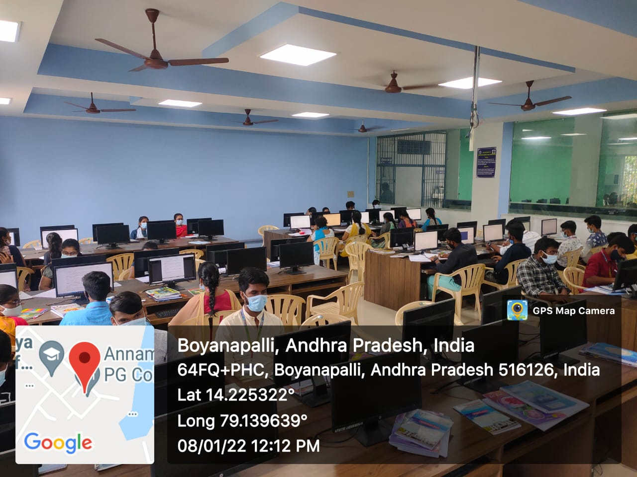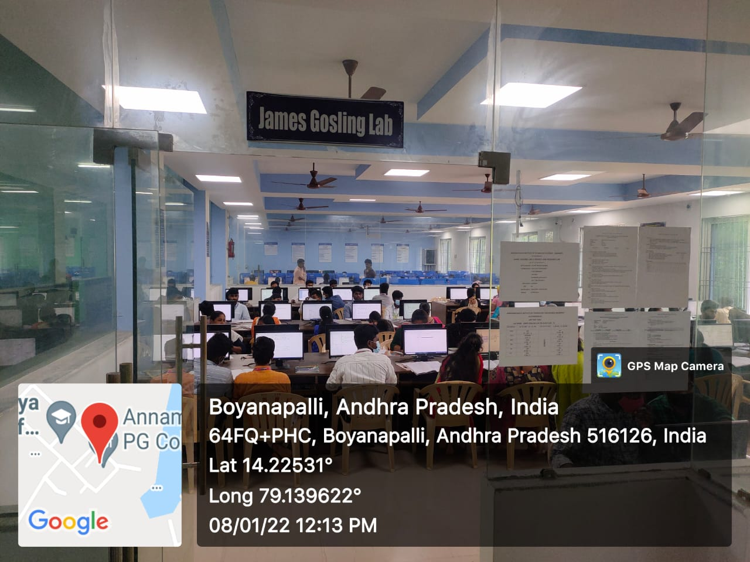
AITS PG PR LAB AITS PG JAMES GOSLING LAB
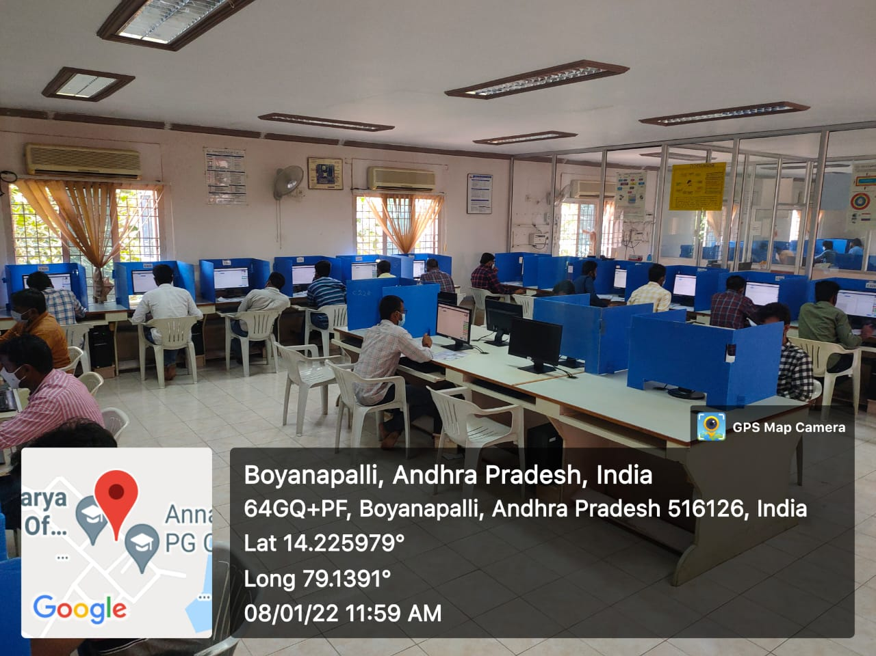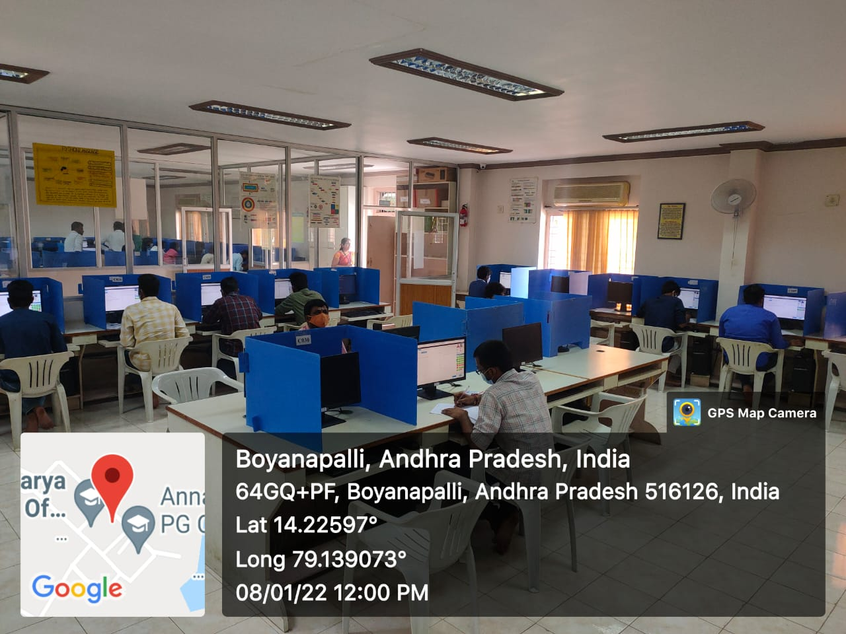
AITS MB JKC LAB AITS MB NUMEN LAB
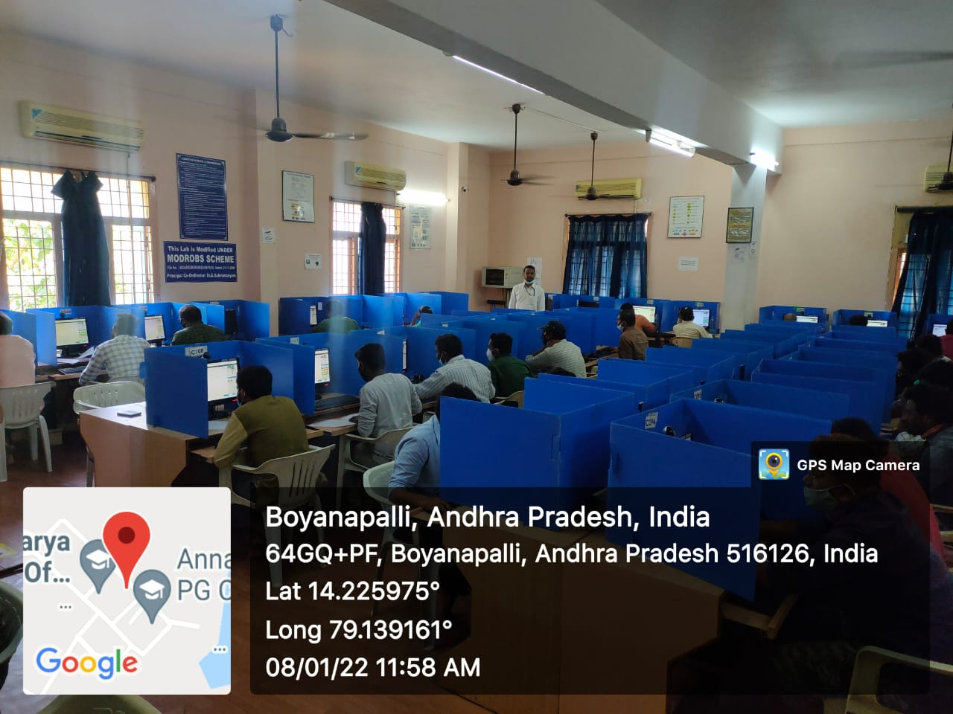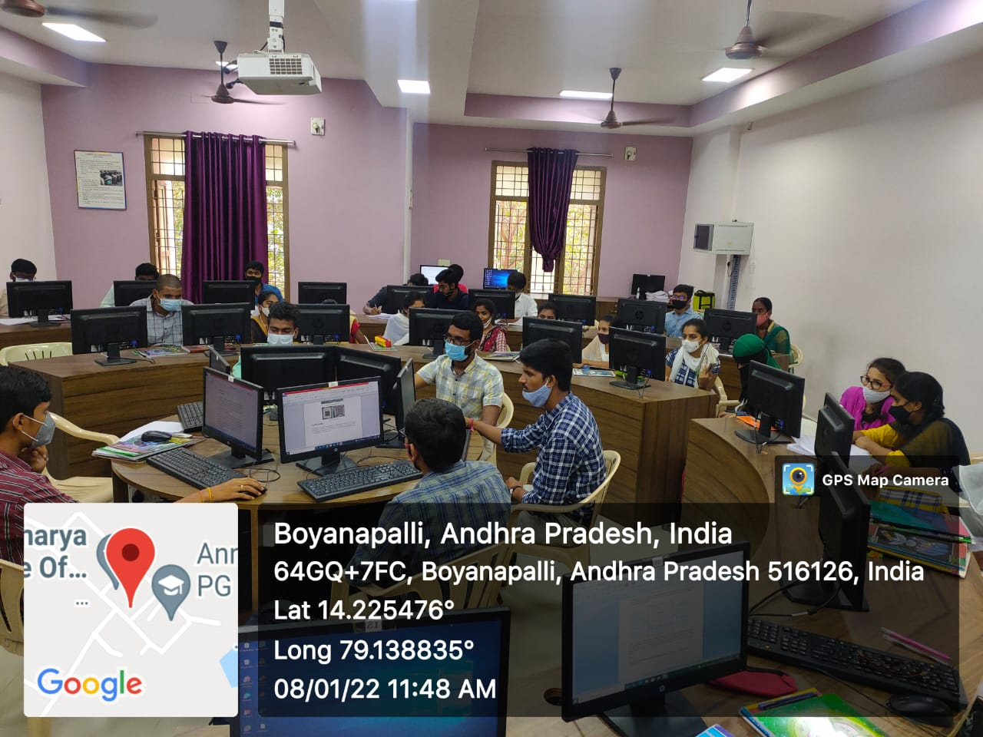
AITS ME ARYABHATTA LAB AITS MB IOT LAB
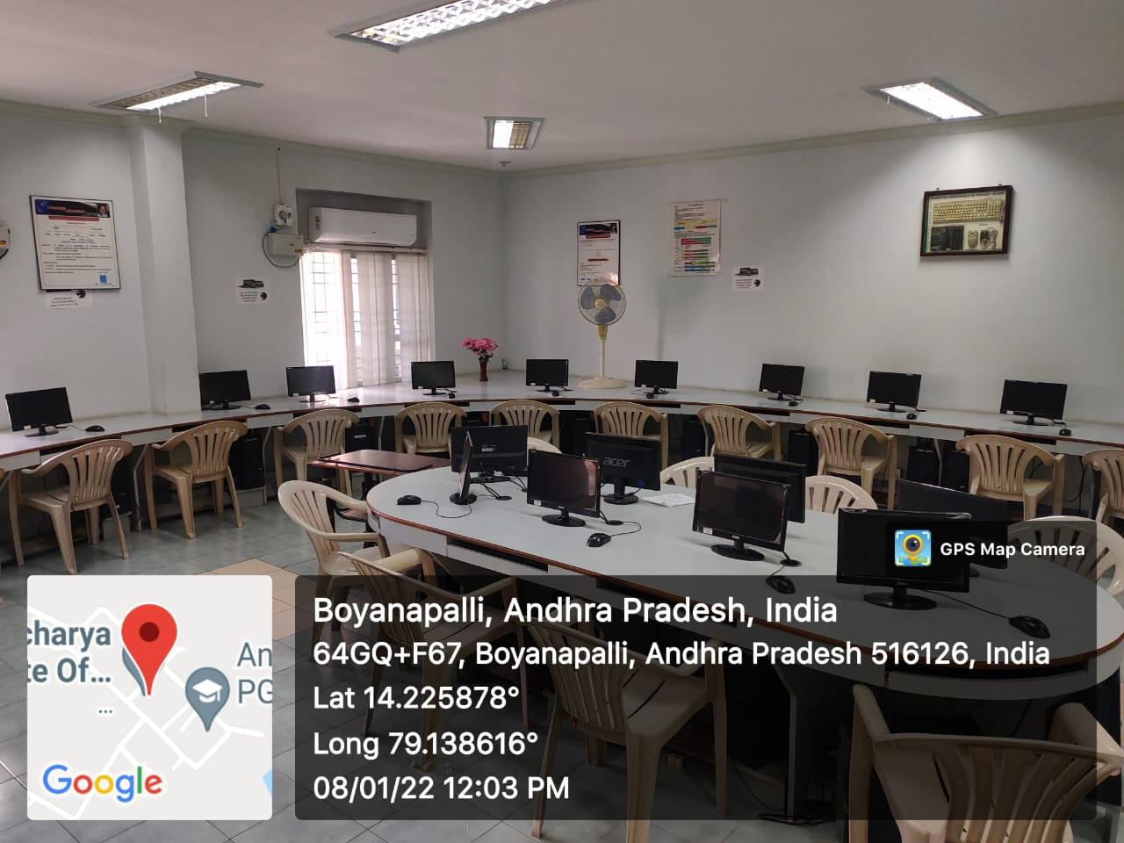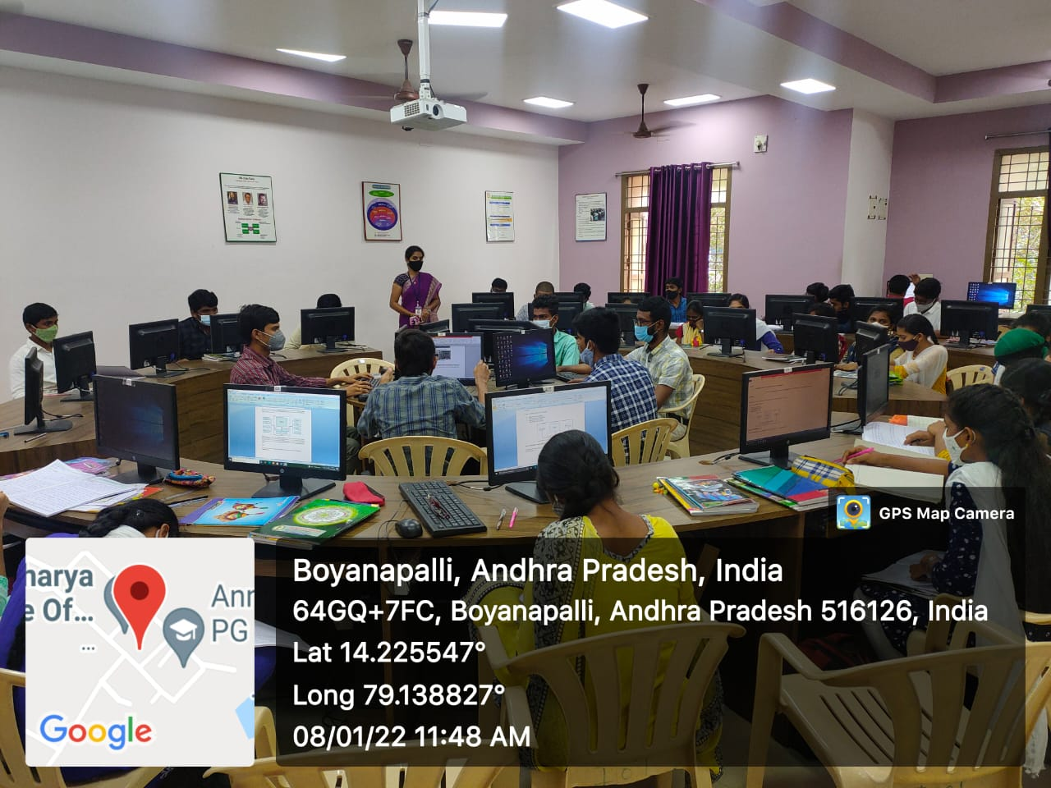
AITS MB BELL LAB AITS MB IOT LAB

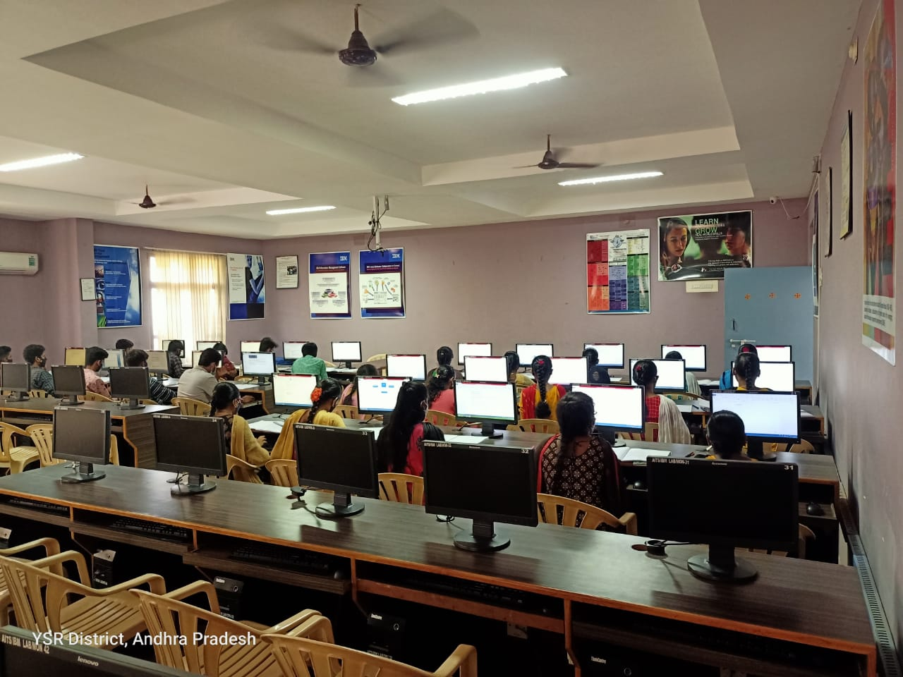
AITS MB IBM LAB

ICT ENABLED CLASS ROOMS

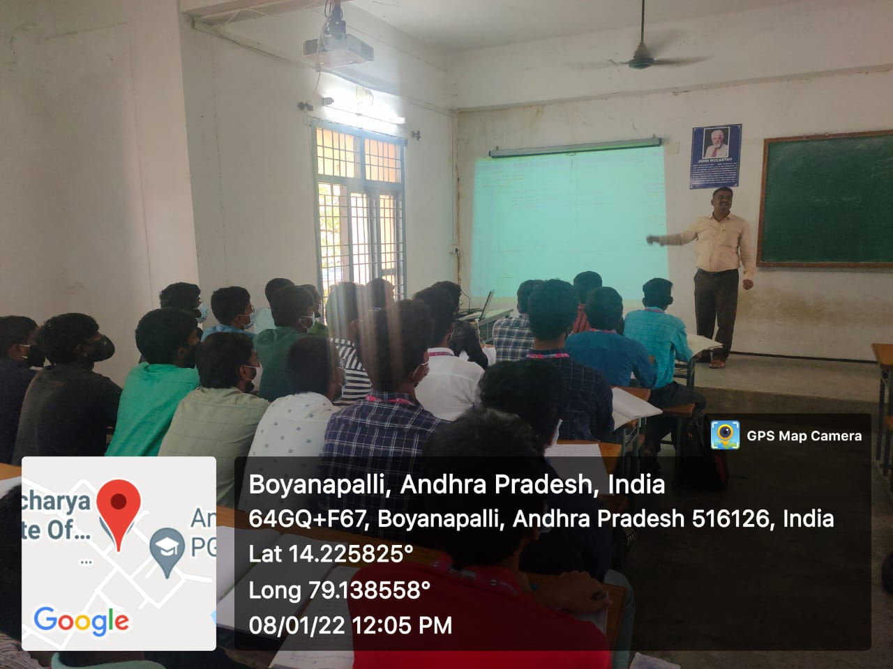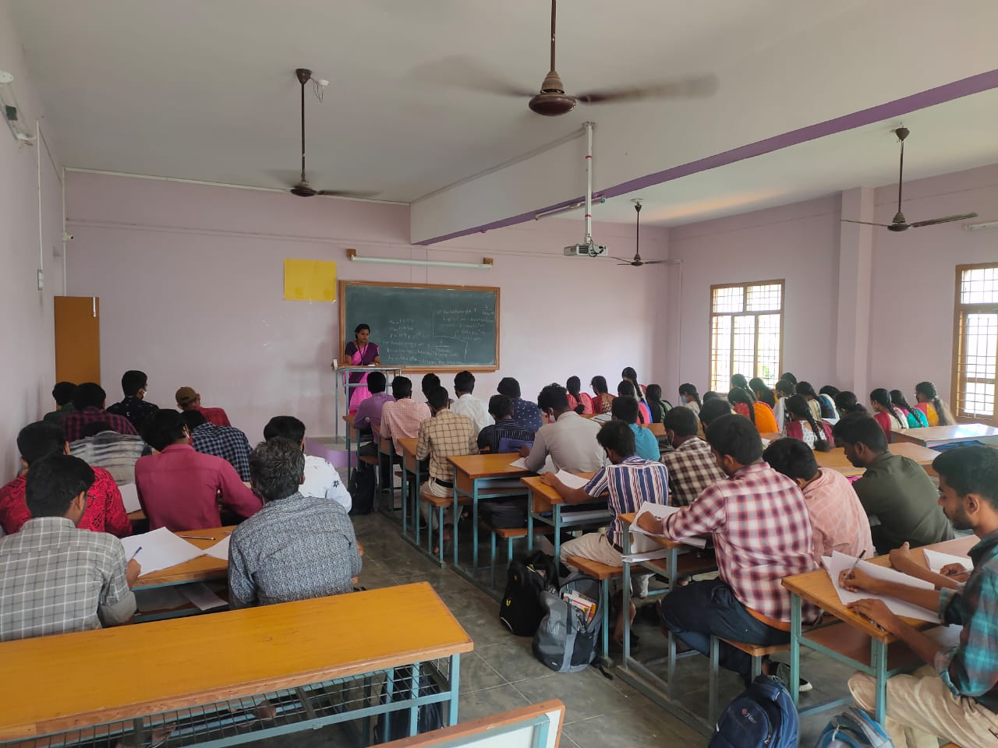
AITS MB ICT CLASS ROOM NO 204 AITS MB ICT CLASS ROOM NO 201

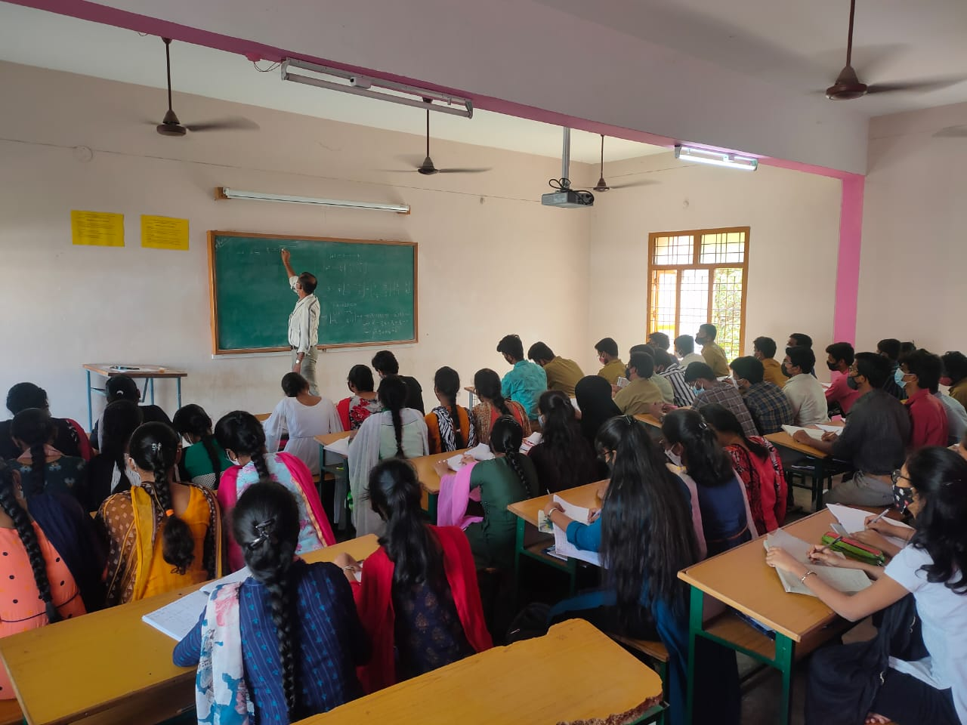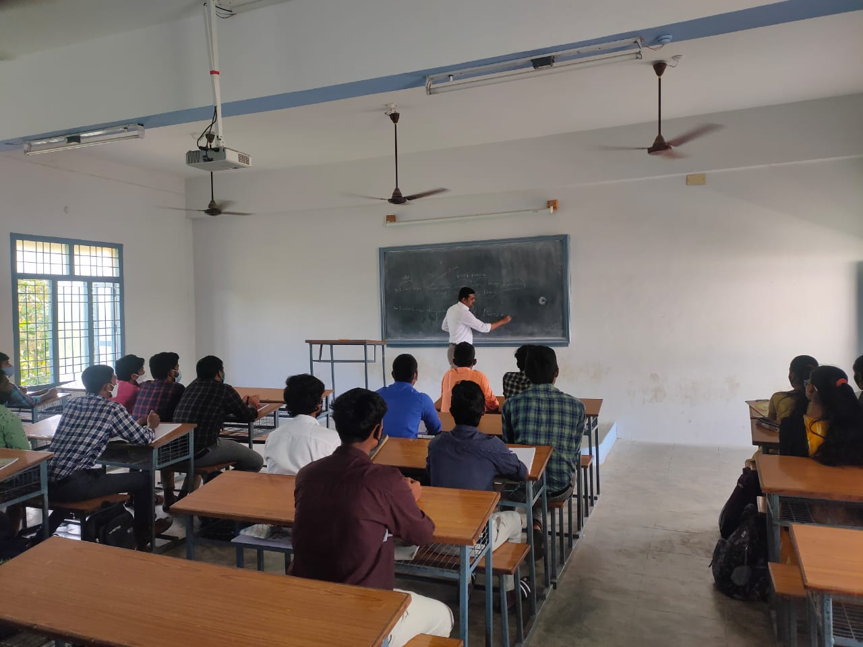
AITS MB ICT CLASS ROOM NO 321 AITS MB ICT CLASS ROOM NO 322
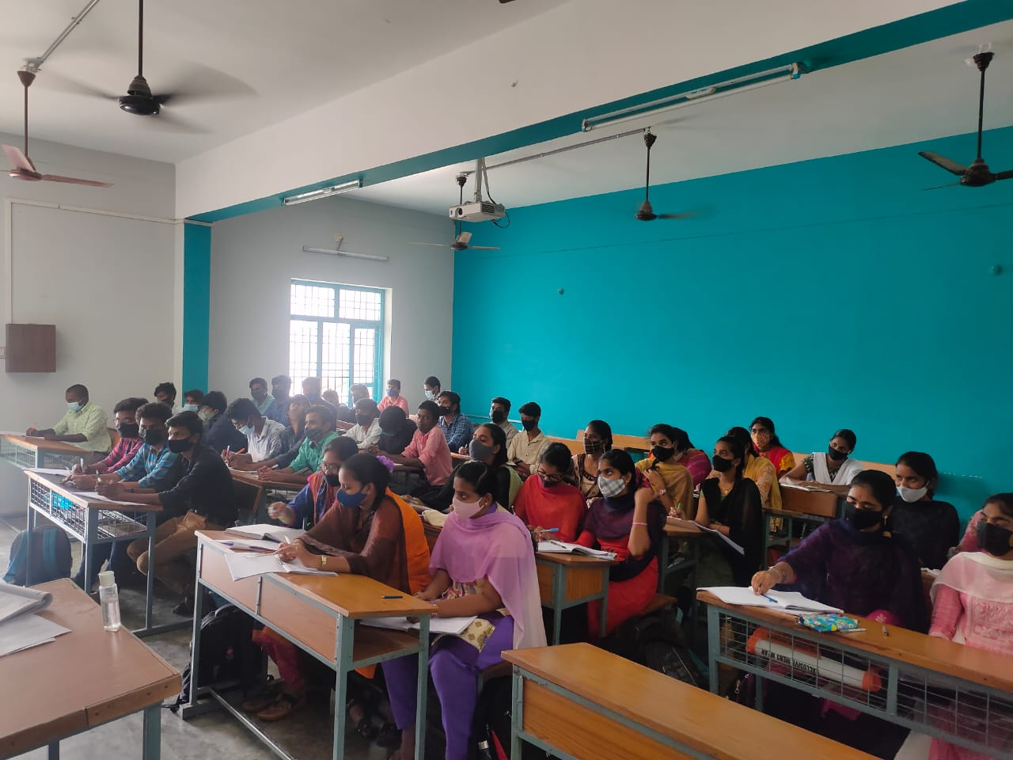
AITS MB ICT CLASS ROOM NO 324 AITS MB ICT CLASS ROOM NO 207

