ANNAMACHARYA
INSTITUTE OF TECHNOLOGY & SCIENCES
(AUTONOMOUS)
New Boyanapalli, Rajampet Annamayya (Dist)– 516126

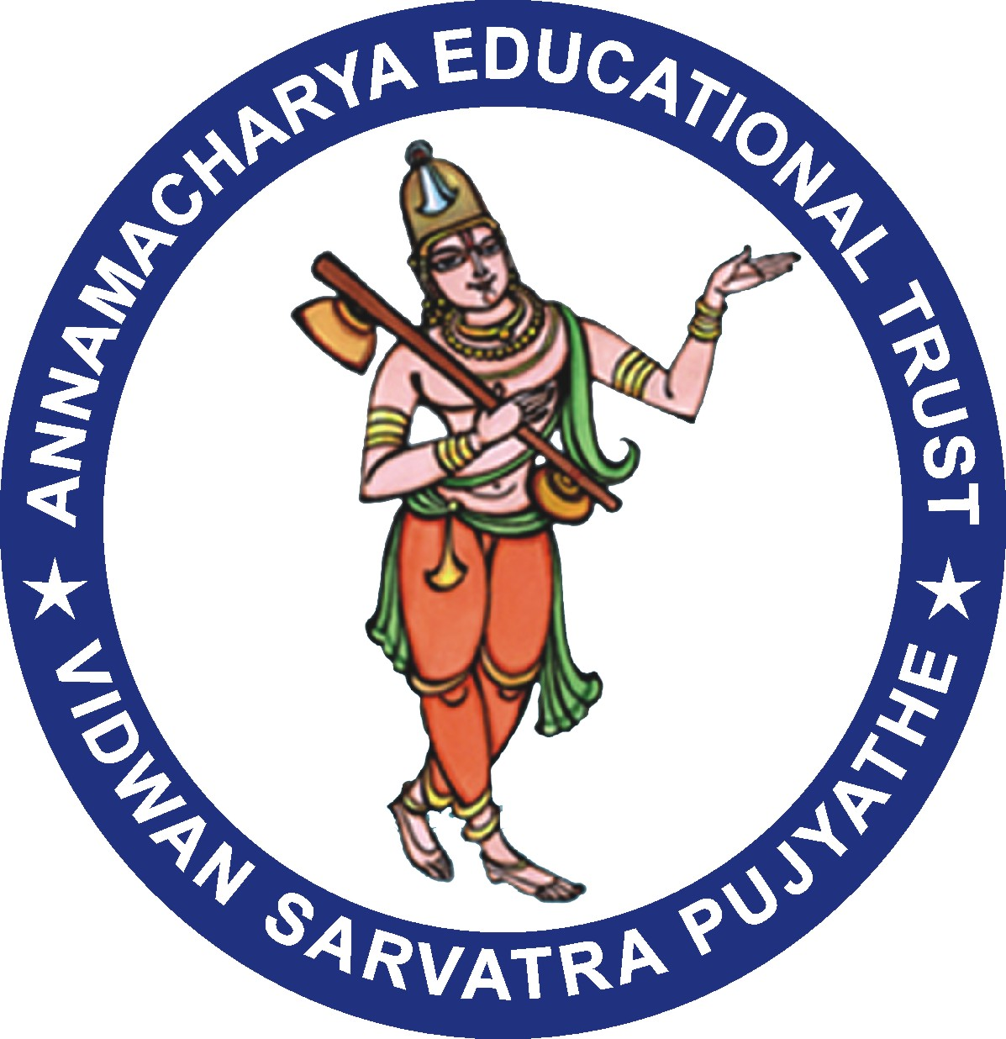

Department of Business Administration

Alumni Meeting Report – 2021

Alumni Meet -2021 is conducted in virtual mode due to COVID-19 Pandemic situation the
Mrs. V. Vedavathi, MBA Department Alumni Coordinator has presented the activities initiated and executed at the department level during the academic year 2020-21. She has presented the opinions expressed by the alumni members in annual meet of Alumni which is held on 12th December, 2021. A total of 105 Alumni attended to the Annual Alumni meet 2021 Several points related to the academics of MBA and the suggestions received from the Alumni were discussed in this meeting. Since the meeting this time is on online mode many people attended the event from different places across the globe.
Dr. P. Subramanyam HOD of MBA Department sharing his happiness by seeing the alumni in renowned position and having expressed their willingness for doing the best for the institution. Most of our alumni are software engineers, designated as top-level executives in leading core companies and Managers in Banks.

Suggestions by the Alumni

- Alumni who were attended to the meetings were expressed their happiness and satisfaction towards the alumni activities.
- To encourage more alumni to attend Alumni meets in the upcoming years

- Suggested to conduct the Alumni activities like invited talks seminars workshops very frequently in the institute which already our institute Alumni Association is conducting.

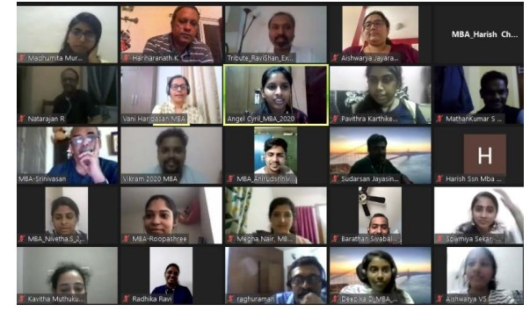
(Alumni Meet on 12th December 2022.)

Alumni Invitation Link:

Meeting Link: https://meet.google.com/trf-ibrd-hgr

Finally, at the end of the programme, Vote of Thanks was given by Mrs Dr T. Navaneetha, Associate Professor, MBA.

Department Alumni Coordinator

