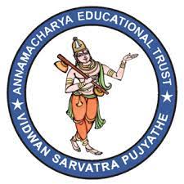
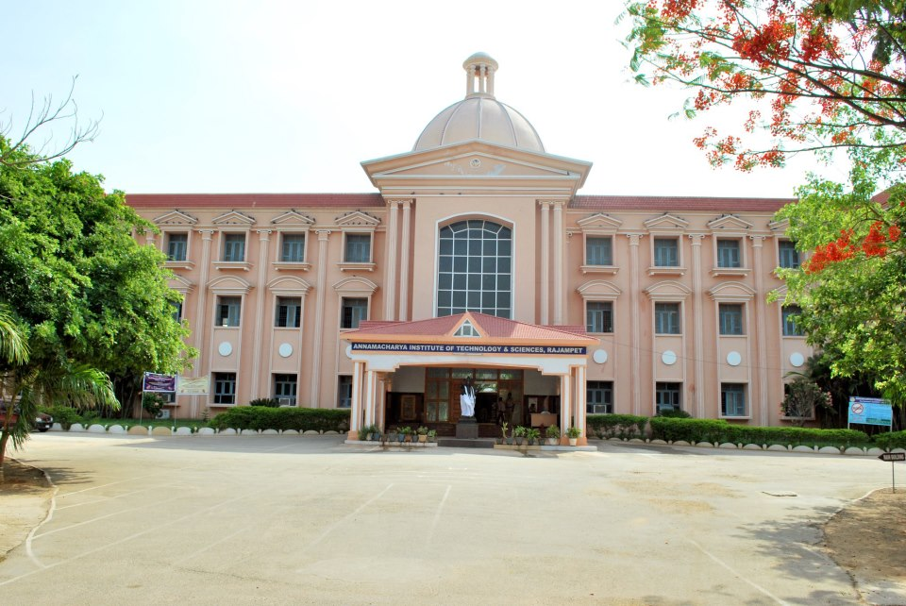Annamacharya
Institute of Technology & Sciences (Autonomous):
Rajampet

PERSONAL GROWTH
AND TEAM BUILDING

Programme Director: Dr.B.Abdul Azeem

Programme Dates: January 20 - 22, 2020

Venue: MBA SEMINAR HALL

INTRODUCTION
The primary purpose of this Programme is to provide participants with an opportunity to learn more about one’s own self as a person so as to become more competent in interpersonal relationships, and learn how their feelings affect and are affected by others’ perceptions and feelings. The programme will also focus on the dynamics of team formation, team norms and team development.

OBJECTIVES
- To help increase individual’s awareness of his/her own perceptions, feelings, reactions, expressions and its impact on others.
- To gain insight into the meaning and consequences of our own behaviors and actions on others’ behaviors and actions.
- To understand and experience the dynamics and processes of team behavior
- To examine the conditions of team effectiveness
- To develop the skills in diagnosing and taking more effective interpersonal and team actions.

PEDAGOGY
Most sessions will be agenda-less team discussions. The data for discussions are the data provided by the interaction of team members as they strive to create a viable society for themselves. Actions, reactions, interactions, and the concomitant feelings accompanying all of these are the data for the team. This experiential learning will be aided and strengthened by brief conceptual and theoretical inputs and exercises. In short, this experience-based learning method aims to develop two basic skills:
  - Conceptual skills: which will serve as tool in linking personal goals, values, and intentions to actions with internal consistency and situational contingency.
  - Behavioral skills: in diagnosing team process and developing task-role and maintenance-role in team work, skills in interpersonal communication and competence in dealing with integration of intentions and actions.

WHO MAY ATTEND
Managers and Executives from all ranks and types of organizations.

PROGRAMME DIRECTOR
Dr.B.Abdul Azeem is a Professor in finance stream. He has versatile experience in management field. He has published various articles and attended various conferences.
He acted as rapporteur for various events organized with in and outside the institution. He has conducted various workshops and events. He got best teacher award for his services in teaching field.

PROGRAMME FACULTY
In addition to Dr.B.Abdul Azeem, the following faculty member will also be the resource person for this MDP:
Dr.T. Navaneetha, Assistant Professor from MBA department has completed her Ph.D. from Sri Padmavathi Mahila Visvavidyalayam. She has 10 years of experience in Research and Teaching. She has published various journals of National and International repute. She has trained many industry experts on various topics like Organizational Behaviors, Stress Management and Work – Life Balance.

PARTICIPANTS’ FEEDBACK

The programme on personal growth and team building has come in very handy as it has helped me not only in understanding of self but also my role both as a team member and in building a team. The programme has allowed me to look into my inner self and taught me a few things which are going to help me in my professional life immensely. When you are performing through a team, there is a basic rule that you should make yourself open. In other words, the programme helped in educating me on the aspects of receiving and giving feedback and the importance of feedback.
I have attended many training programs but this one was a unique course. Here we learnt much more about human behavior, decision making in a team, building a good team, giving/receiving affection, how to be inclusive. We learnt how to improve our blind spots.

Dr.T. Navaneetha teaching style is great. She tends to bring team involvement in all sessions. Very impressive programme.
Program 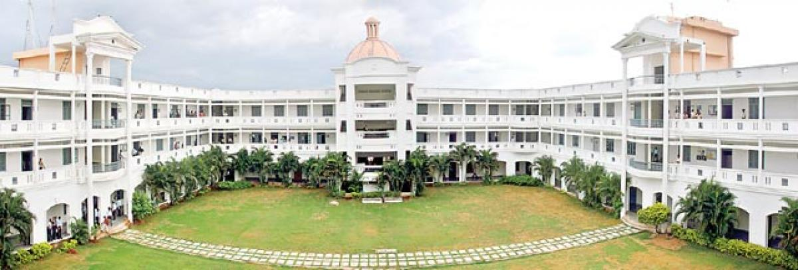
e Commencement: 9:00 AM on March 11, 2024
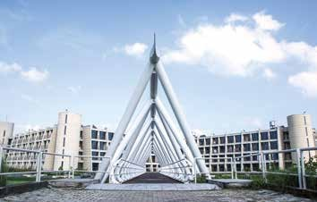
PROGRAMME DETAILS
Duration: January 20 -22, 2020
Programme Commencement: 9:30 AM on January 20, 2020
Programme Conclusion: 2:00 PM on January 22, 2020
Venue: AITS MBA Seminar Hall
Accommodation: For Residential participants
Check in: January 19, 2020 (6:00 pm onward)
Check out: January 22, 2020 (2:00 pm)

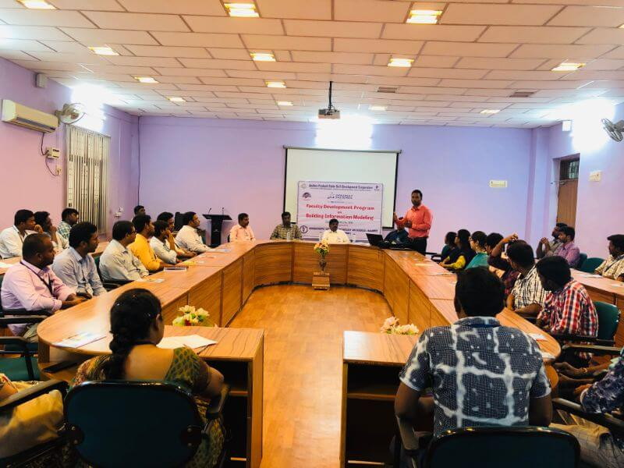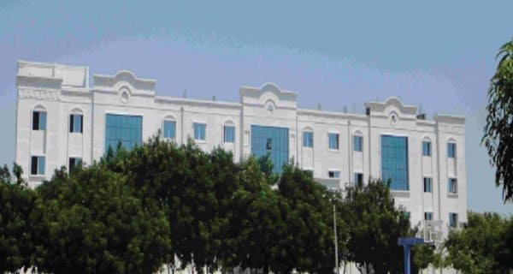

PROGRAMME FEES
Residential (R): 2500/- only.
Non-Residential (NR): 2000/-.
We would strongly encourage candidates to enroll as Residential participants, as the experience of an MDP is optimized in a full-immersion mode.
Discount on Programme fees:
A discount of 10% on the Programme fees can be availed by an organization if it nominates at least 4 participants for a particular MDP.

TERMS & CONDITIONS
- Participants would have to make their own travel arrangements.
- Accommodation at AITS will be provided till 2.00 p.m. on January 22, 2020. Participants staying beyond this time will have to bear additional stay and food charges, which they have to settle directly with the hospitality service provider, conditional upon room availability.
- Cancellation Policy: In case you/your nominated candidate(s) does(do) not attend the programme, 40% of the programme fees will be retained, as per policy.

AITS Campus Small Group Session

HOW TO APPLY
- You can apply/nominate your personnel by clicking on the “Apply Now” link corresponding to the particular MDP, as appearing on our online calendar available at: https:// pgtbaits@gmail.com
- Once the candidature(s) is (are) approved, he sponsoring authority or participant (in case of self-nomination) will be intimated over email along with the Payment Advice seeking programme fees in advance.
- Programme fees can be remitted online through Electronic Fund Transfer (NEFT/RTGS).
- Upon remitting the fees online, kindly intimate AITS office with the UTRNo. /relevant transaction details through email, so that we can connect your remittance to your nomination(s). Please note that confirmation of participation is subject to receipt of Programme fees by AITS Office before commencement of the MDP.
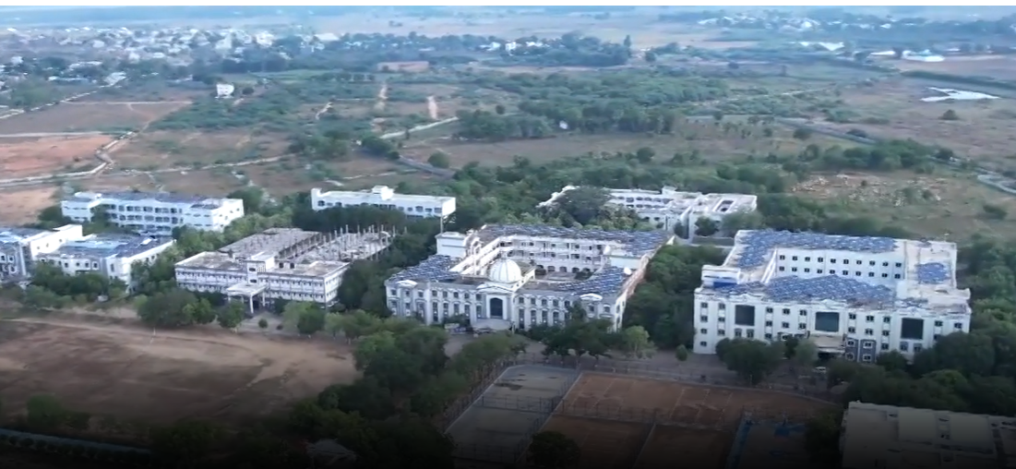

Our correspondence address is as follows:
AITS Office
Annamacharya Institute of Technology and Sciences, (Autonomous)
New Boyanapalli, Rajampet Andhra Pradesh Phone: +: 251863/251864
Pin Co 516126 Email: aitsrjp@gmail.com |

For further Clarifications, contact:

Dr.B.Abdul Azeem, Program Coordinator, Phone number: 7093769885,

email id: pgtbaits@gmail.com

